05/01/21

**THM 121 Business Mathematics**

**Final Exam Answer Sheet**

**Note to the students**:

* Calculations to reach your answers shall be thoroughly shown. Otherwise, questions will NOT be graded.
* You can use a calculator throughout the exam.

1. Consider the following equation of a line: 4χ + 3y = 5
2. Find the equation of the line that passes through the point (-2, 3) and is **perpendicular** to the line 4χ + 3y = 5. (**3** Points)

4χ + 3y = 5 ↔ 3y = -4χ + 5 ↔ y = (-4/3)χ + (5/3). This implies that the slope of the line perpendicular to the one in question a) shall have a slope of **3/4**. Using the point (-2, 3), we get the following equality: (3/4)*(-2) + *b* = 3 ↔ (-3/2) – 3 = - b ↔ b = **(9/2)**. Therefore, the equation of the line that passes through the point (-2, 3) and is perpendicular to the line 4χ + 3y = 5 is:

**y = (3/4)χ + (9/2)**.

1. Sketch the **graph** of the line found in part a). (**2** Points)
2. A certain stock had an initial public offering (IPO) price of **$ 10 per share** and is traded 24 hours a day. Sketch the graph of the share price over a 2-year period for each of the following cases:
3. The price **increases** steadily to **$ 50** *over the first 18 months* and then **decreases** steadily to **$ 25** per share *over the next 6 months*. (**2** Points)

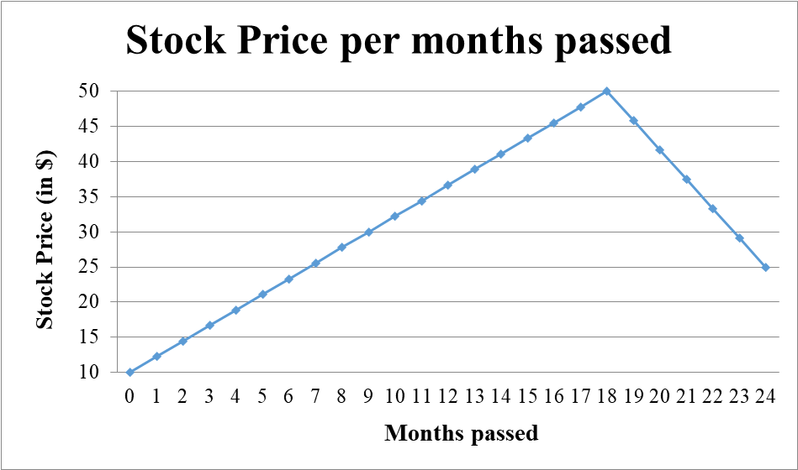

1. The price takes just *2 months* to **rise** at a constant rate to **$ 15** a share and then slowly **drops** to **$ 8** *over the next 9 months* before steadily **rising** to **$ 20**. (**2** Points)

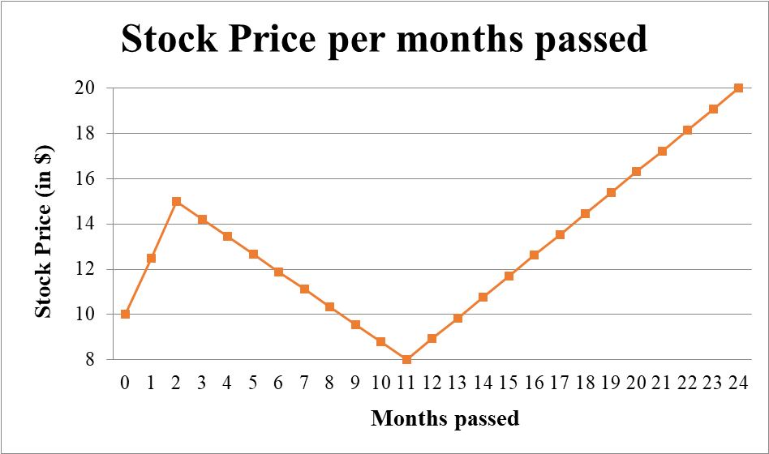

1. The price steadily **rises** to **$ 60** a share *during the first year*, at which time an accounting scandal is uncovered. The price **goes down** to **$ 25** a share and then steadily **decreases** to **$ 5** over the next 3 months before **rising** at a constant rate to close at **$ 12** at the end of the 2-year period. (**3** Points)

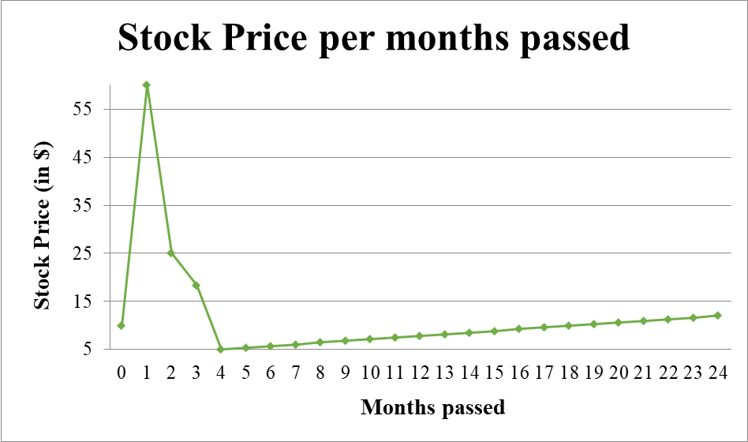

3) Farmers can get **$ 8** per bushel for their potatoes on July 1, and after that, the price drops by **5** cents per bushel per day. On July 1, a farmer has **140 bushels** of potatoes in the field and estimates that the crop is **increasing** at the rate of 1 bushel per day.

a) Express the farmer’s **revenue** from the sales of the potatoes as a function of the **time** at which the crop is harvested. (**2** Points)

Let χ denote the number of days after July 1 and *R*(χ) the corresponding revenue (in dollars). Then R(χ) = (Number of bushels sold) * (Price per bushel). Since the cop increases at the rate of 1 bushel per day and 140 bushels were available on July 1, then the number of bushels sold after χ days (i.e. days after July 1) is **140 + χ**. Moreover, since the price per bushel decreases by 0.05 dollars per day and was $ 8 on July 1, the price per bushel after χ days (i.e. days after July 1) is **8 – 0.05 χ**. Therefore, *R*(χ) = (140 + χ) * (8 – 0.05 χ) = **- 0.05 χ2 + χ + 1120**.

b) **Sketch** the graph of the function found in part a). (**3** Points)

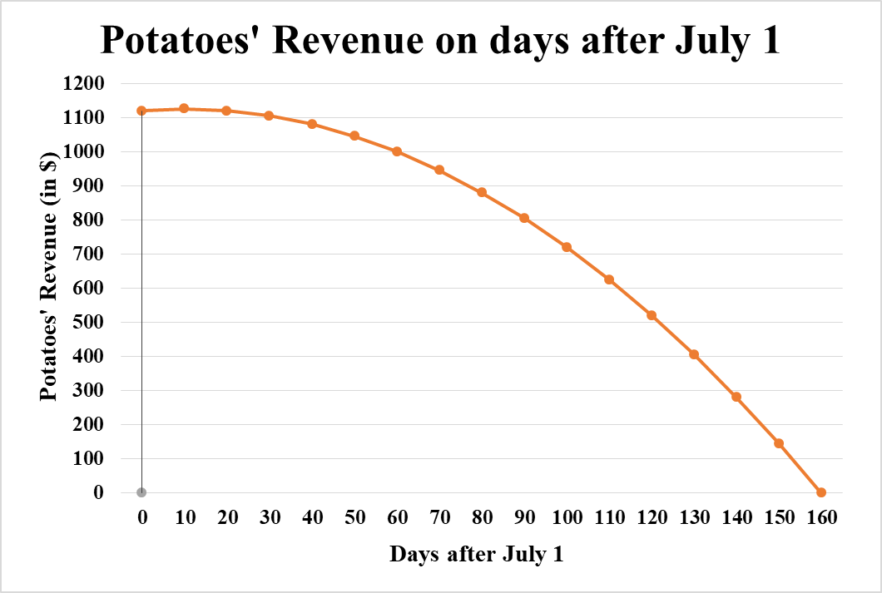

1. Estimate **when** the farmer should harvest the potatoes to **maximize revenue**. (**2** Points)

The number of days to maximize revenue is 10 days after July 1 (i.e. **July 11**).

1. Producers will supply χ units of a certain commodity to the market when the price is *p* = *S*(χ) dollars per unit, and consumers will demand (i.e. buy) χ units when the price is *p* = *D*(χ) dollars per unit, where

***S*(χ) = 3χ + 25 and *D*(χ) = 415 / (2χ + 1)**

1. Find the **equilibrium production level** χ, and the **equilibrium price** *pe*. (**2** Point)

Equilibrium occurs when *S*(χ) = *D*(χ) ↔ 3χ + 25 = 415 / (2χ + 1) ↔ (3χ + 25) * (2χ + 1) = 415 ↔ 6χ2 + 53χ – 390 = 0. Using the quadratic formula, ∆ = (53)2 – (4)(6)(-390) = 2809 + 9360 = 12169. Therefore, $x=\frac{-53±\sqrt{12169}}{12}$. So χ = **4.78** **units** (disregard the negative root). The corresponding equilibrium price is *pe* = 3(4.78) + 25 = **$ 39.33**.

1. Draw the **supply** and **demand** curves on the same graph. (**3** Points)

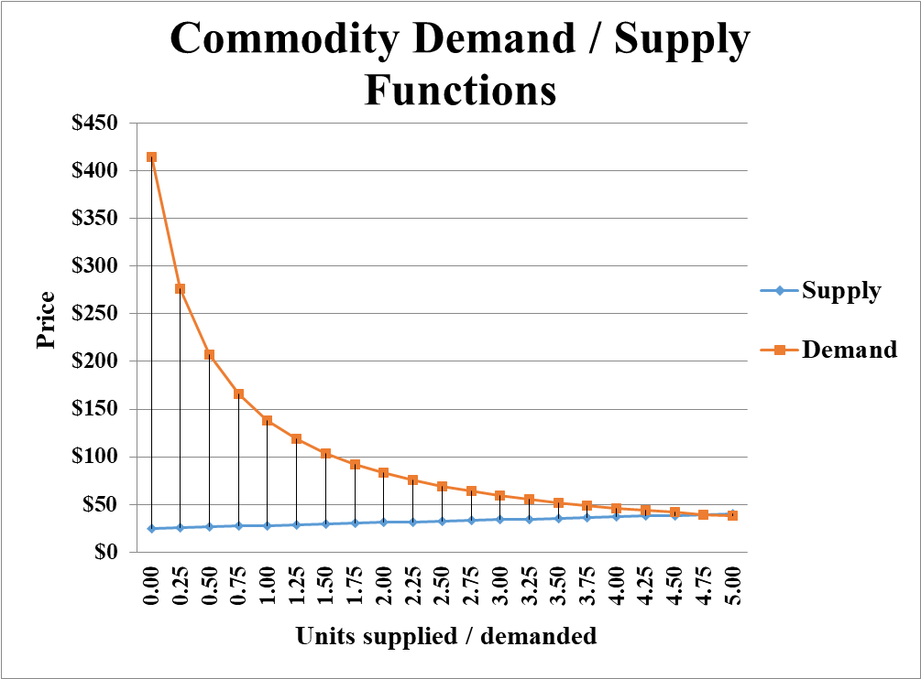

1. Where does the supply curve **cross the y axis**? Describe the **economic significance** of this point. (**2** Points)

The supply curve intersects the y-axis at *S*(0) = $ 25. Since this is the price at which producers are willing to supply no (i.e. 0) units, it corresponds to their overhead (i.e. fixed cost) at the start of the production.

1. Studies indicate that *t* years from now, the population of a certain country will be *p* = 0.2*t* + 1,500 thousand people, and that the gross earnings of the country will be *E* million dollars, where

***E (t*) = $\sqrt{(9t^{2}+0.5t+179)}$**

1. Express the per capita earnings of the country **P** = E / P as a function of time t. (Take care with the units) (**2** Points)

Since the units of *p* are thousands and the units of *E* are millions, the units of *E / p* will be in thousands. Therefore, thousand dollars per person.

1. Draw the graph of per capita earnings function of time? (**3** Points)

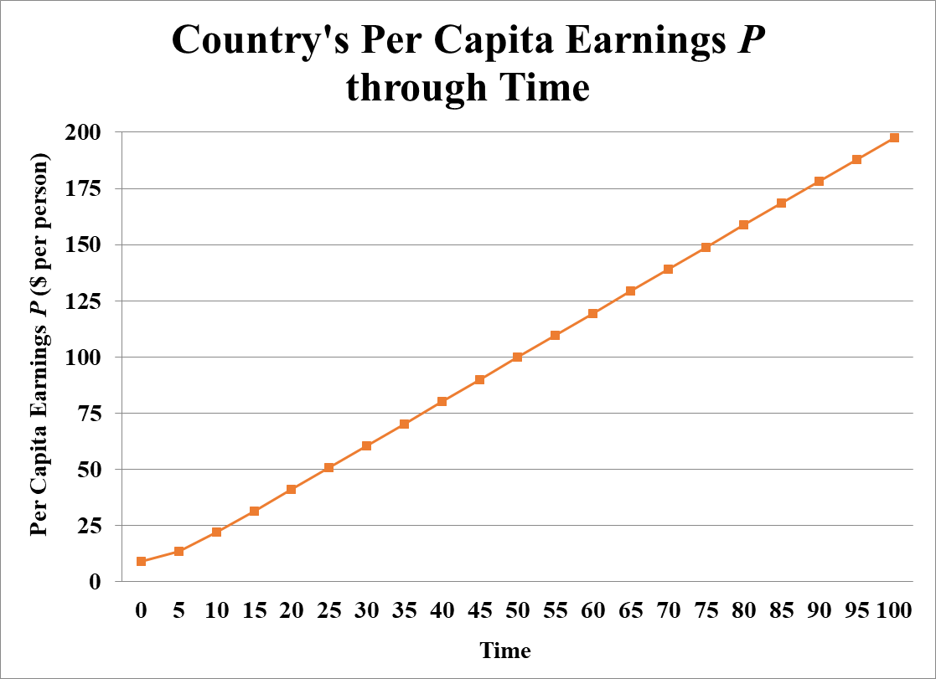

1. What happens to the **per capita earnings** in the long run (i.e. as ***t*** → **∞**)? (**2** Points)

Dividing each term t (note that each term under the square root will be divided by t2 since   


Therefore, as ***t*** moves to infinity (**∞)**,country’s Per Capita Earning ***E*** will move towards **$ 15,000** **per person**.

1. If the air temperature on a given day is **80°F**, the heat index *I*(*h*) (also in °F) can be approximated by the following piecewise function, where *h* is the relative humidity as a percentage:

***I* (*h*) = $\left\{\begin{aligned}80 if 0≤h≤40 \\ 80+0.1\left(h-40\right) if 40<h≤80 \\ 0.005h^{2}-0.65h+104 if 80<h≤100\end{aligned}\right.$**

1. Sketch the graph of I(*h*)? (**3** Points)

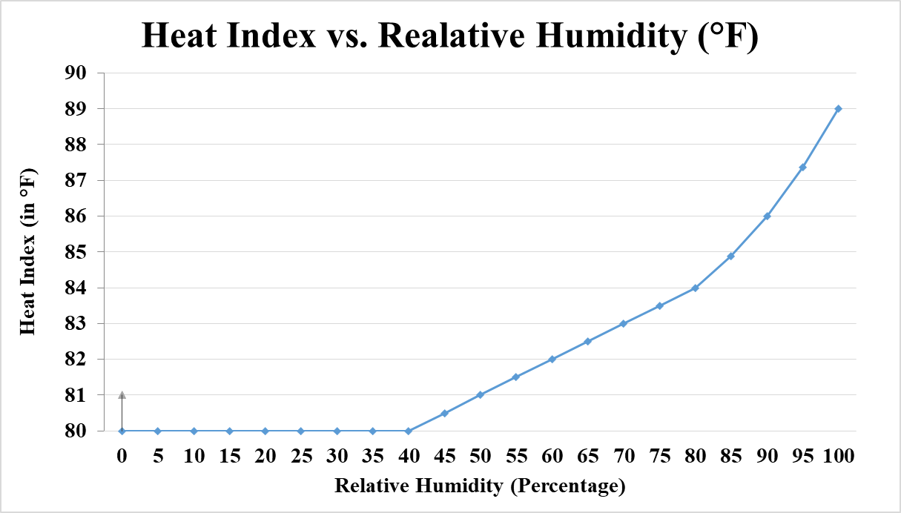

1. What **relative humidity** produces a heat index of **83°F**? (**1** Point)

First, whenever 0 ≤ *h* ≤40, the heat index is 80°F. Using the middle branch of the function, 83 = 80 + 0.10 (*h* – 40) ↔ *h* =70. A relative humidity of **70 %** produces a heat index of 83°F. Using the bottom branch of the function,   
  
for which there is no solution.

1. Is the heat index function I(*h*) **continuous** at *h* = 40? What about at *h* = 80? (**3** Points)

**  
**Since I(40) =80, function **I (*h*) is continuous at *h* = 40**.

  


Since I(80) =84, function **I (*h*) is continuous at *h* = 80**.

**N.B**. Round your answers to the **nearest cent** for questions 2, 3, 4, 5 & 6.

**GOOD LUCK!**